23.22: a)
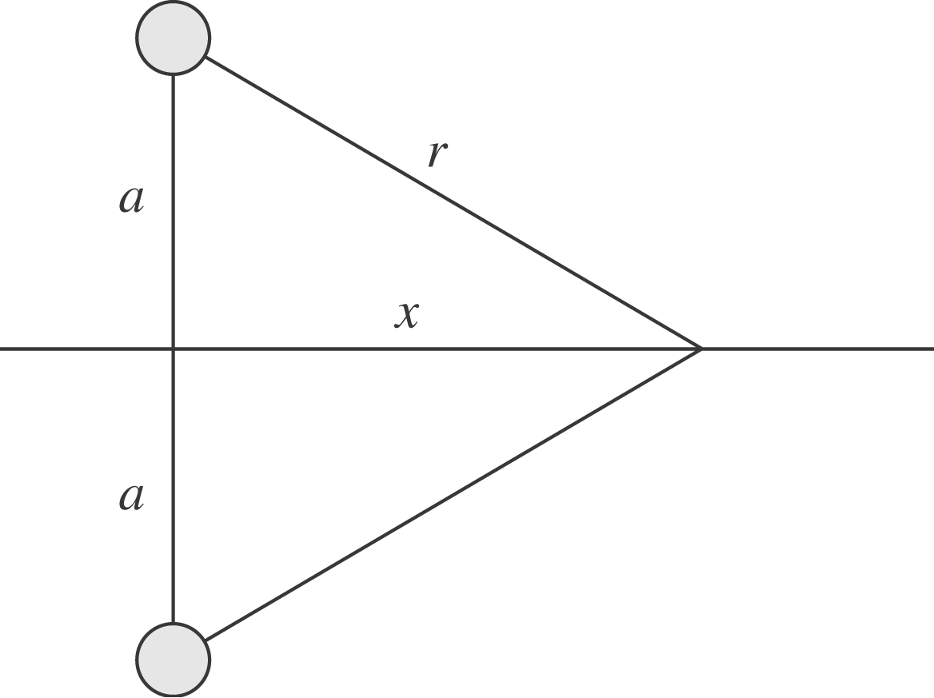
b) 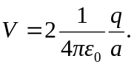
c) Looking at the diagram in (a):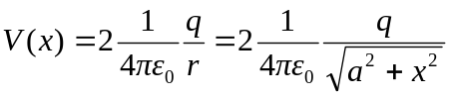
d)
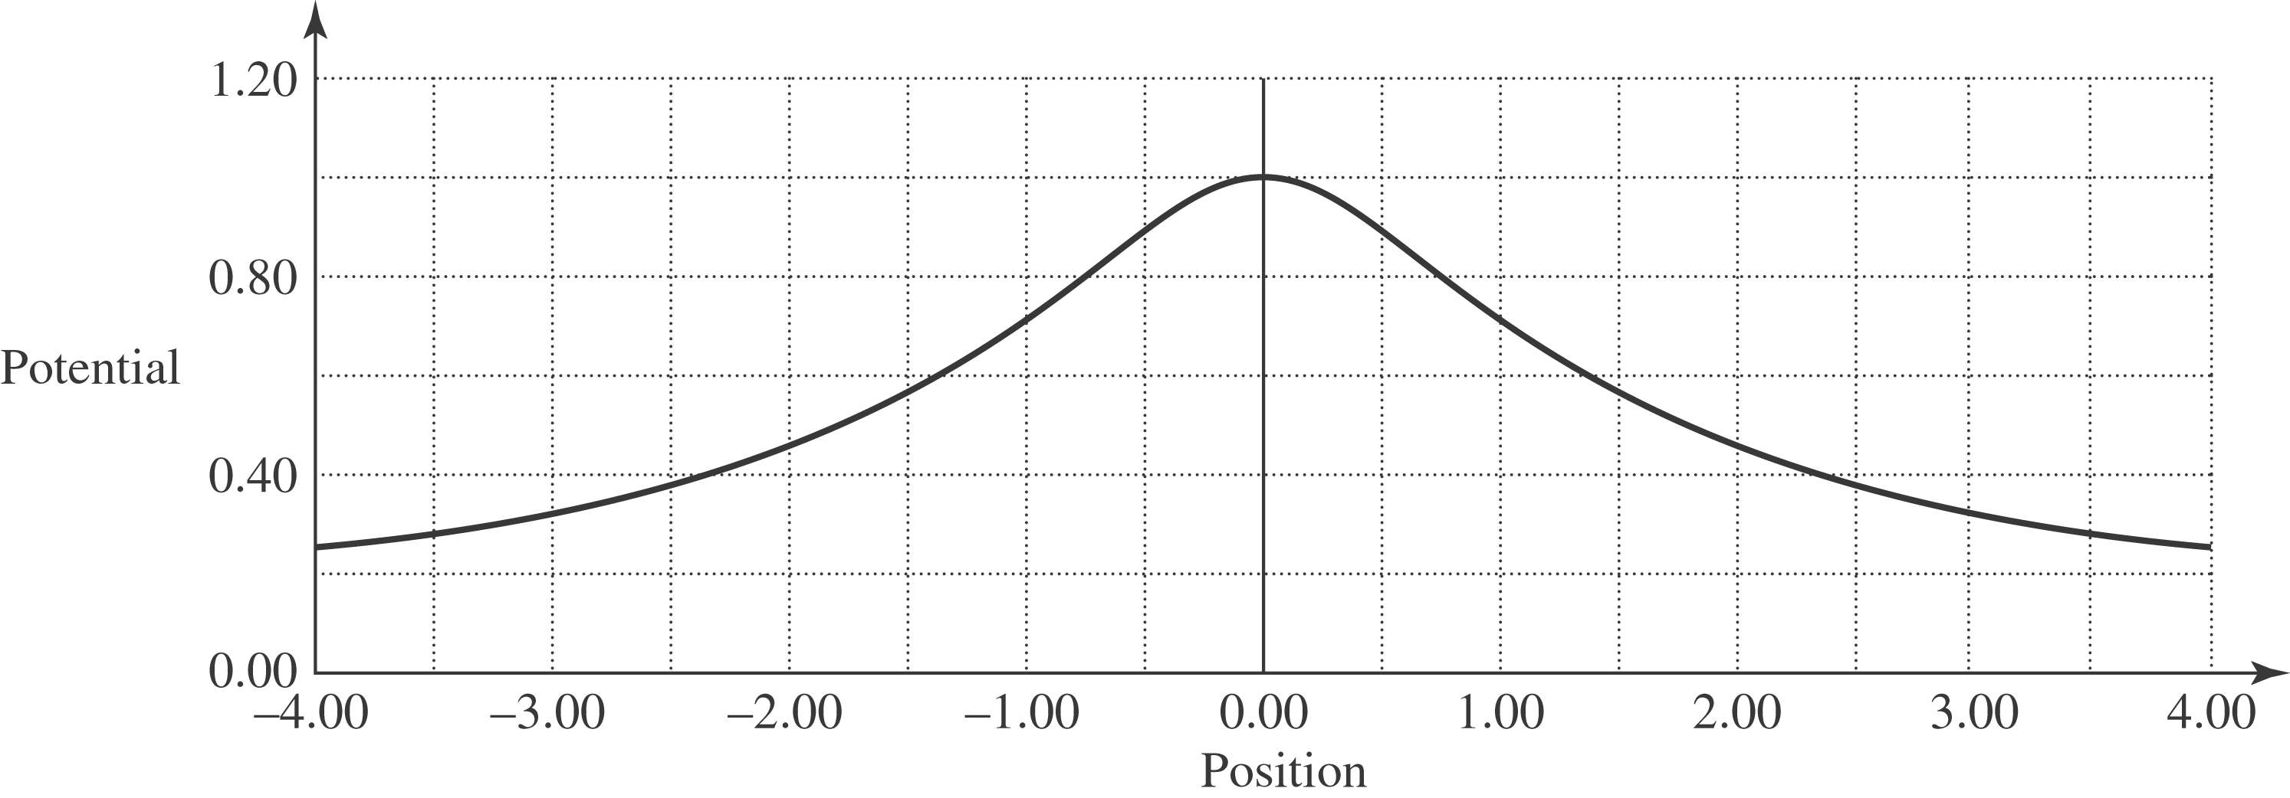
e) When 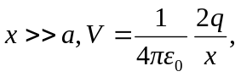just like a point charge of charge 